**Library Module – Static Library**

1. Create 3 files as below. Let cal_utility.c, .h files be part of the library

· libapplication.c – will contain main() and will invoke functions in cal_utility.c.

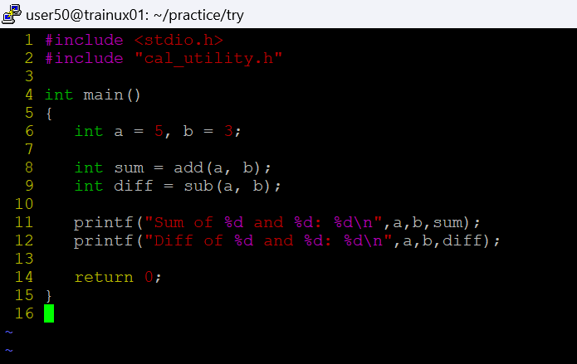

· cal_utility.c – will contain atleast 2 or more functions [ You may add definitions of the functions in this file ]

· cal_utility.h – will contain the extern declarations/prototypes of the functions in cal_utility.c

2. Refer the steps for static library based application and create a static library application using above set of files.

3. Execute the application created in step #2

